**Lab Pandas Dataframe (Day-26)**

**Lab1: Write a Pandas program to create a dataframe from a dictionary and**

**display it.**

**Sample data:**

**score={'Math':[78,85,96,80,86], 'English':[84,94,89,83,86],'Hindi':[86,97,96,72,83]}**

**Output:**

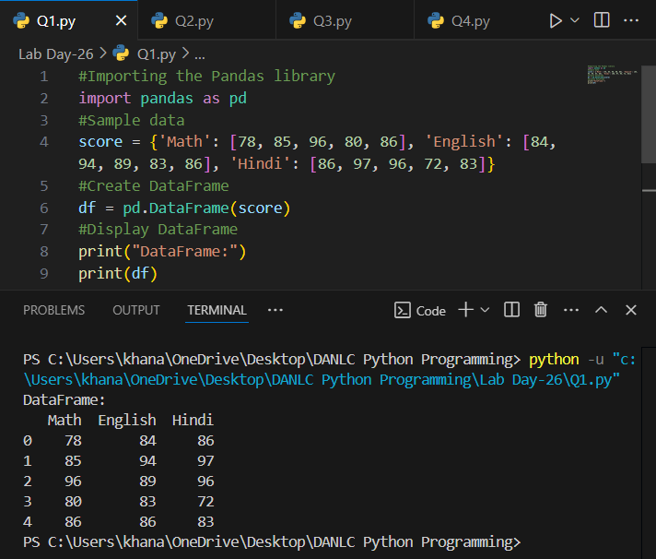

**Lab2: Write a Pandas program to create and display a DataFrame from a**

**specified dictionary data which has the index labels.**

**Sample Python dictionary data and list labels:**

**exam_data = {'name': ['Anastasia', 'Dima', 'Katherine', 'James', 'Emily',**

**'Michael', 'Matthew', 'Laura', 'Kevin', 'Jonas'],**

**'score': [12.5, 9, 16.5, np.nan, 9, 20, 14.5, np.nan, 8, 19],**

**'attempts': [1, 3, 2, 3, 2, 3, 1, 1, 2, 1],**

**'qualify': ['yes', 'no', 'yes', 'no', 'no', 'yes', 'yes', 'no', 'no', 'yes']}**

**Output:**

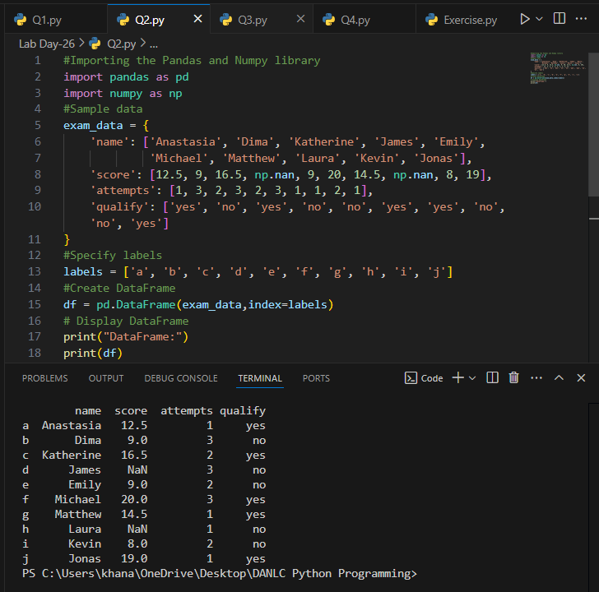

**Lab3: Write a Pandas program to get the first 3 rows of a given DataFrame.**

**Sample DataFrame:**

**exam_data = {'name': ['Anastasia', 'Dima', 'Katherine', 'James', 'Emily',**

**'Michael', 'Matthew', 'Laura', 'Kevin', 'Jonas'],**

**'score': [12.5, 9, 16.5, np.nan, 9, 20, 14.5, np.nan, 8, 19],**

**'attempts': [1, 3, 2, 3, 2, 3, 1, 1, 2, 1],**

**'qualify': ['yes', 'no', 'yes', 'no', 'no', 'yes', 'yes', 'no', 'no', 'yes']}**

**Output:**

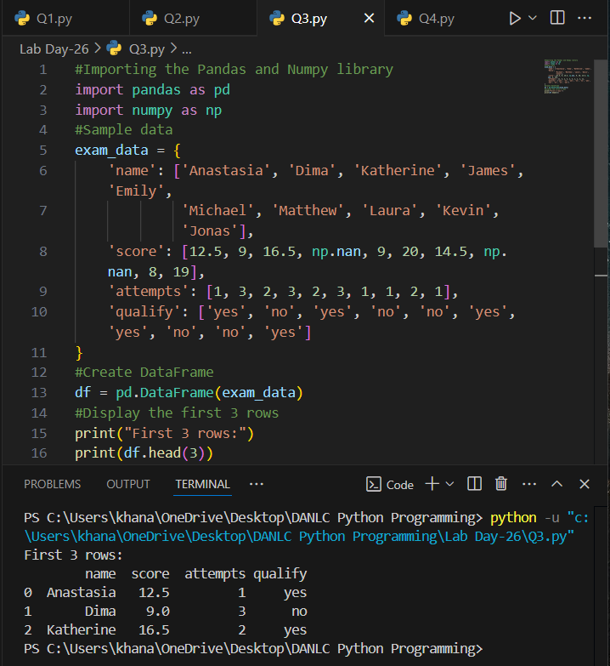

**Lab4: Write a Pandas program to select the 'name' and 'score' columns**

**from the following DataFrame.**

**Sample Python dictionary data and list labels:**

**exam_data = {'name': ['Anastasia', 'Dima', 'Katherine', 'James', 'Emily',**

**'Michael', 'Matthew', 'Laura', 'Kevin', 'Jonas'],**

**'score': [12.5, 9, 16.5, np.nan, 9, 20, 14.5, np.nan, 8, 19],**

**'attempts': [1, 3, 2, 3, 2, 3, 1, 1, 2, 1],**

**'qualify': ['yes', 'no', 'yes', 'no', 'no', 'yes', 'yes', 'no', 'no', 'yes']}**

**Output:**

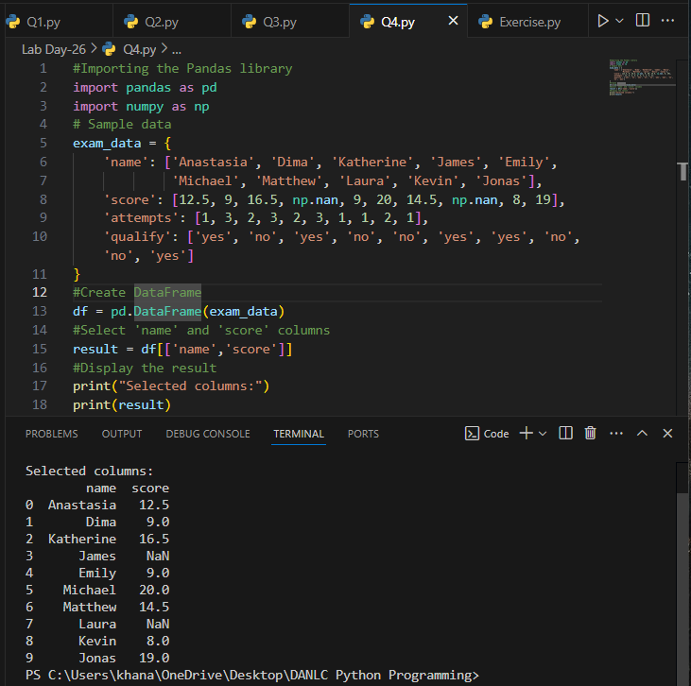

**ChatGPT Exercise**

**Using ChatGPT generate the python code to solve the same problem**

**Scenario: Analyzing Sales Data**

**Suppose you work for a retail company, and you have a dummy dataset containing**

**sales data for the past year. The data includes information such as customer names,**

**product names, sales quantities, prices, and dates. You want to perform various data**

**analysis tasks like Total revenue for the year,Average revenue per sale,Best-selling**

**product,Date with the highest total revenue also wants to generate product and total**

**sales wise barchart using Pandas DataFrames.**

**Further, you need to get some inference out of the chart.**

**Create a ChatGPT prompt to generate the code for this scenario. Based on the code**

**generated, ask ChatGPT to give the conclusion/inference.**

**Note. You can provide the data to ChatGPT in the form of a list or dictionary or ask it to use sample data.**

**Output:**

**1.**

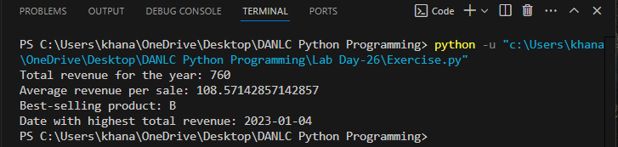

**2.**

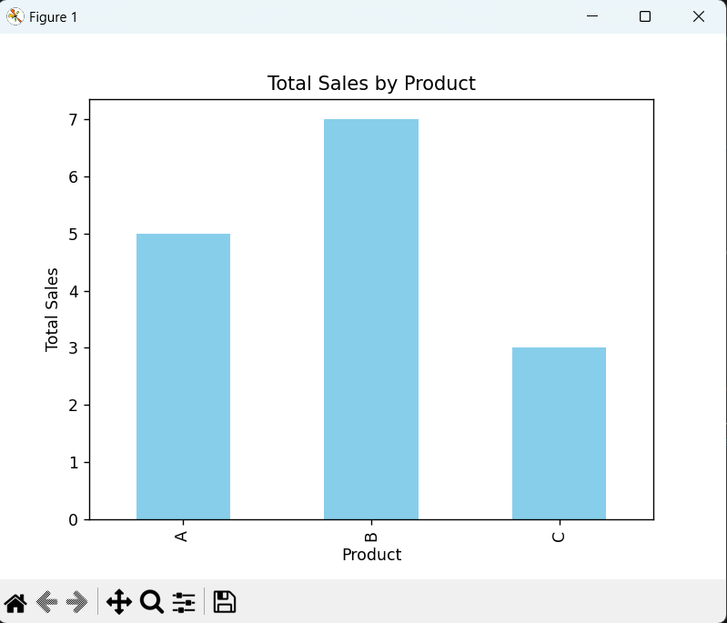

**3.**

